JENKINS INSTALLATION

* Installation process of jankins using the amazon linux AMI.
* Sign in to the the [AWS Management Console](https://console.aws.amazon.com/ec2/).
* Open the Amazon EC2 console by selecting EC2.
* From the Amazon EC2 dashboard, select **lunch instance.**
* **Give name of instance and select the AMI type as AMAZON LINUX.**

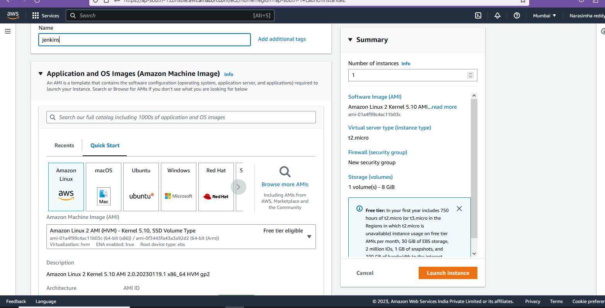

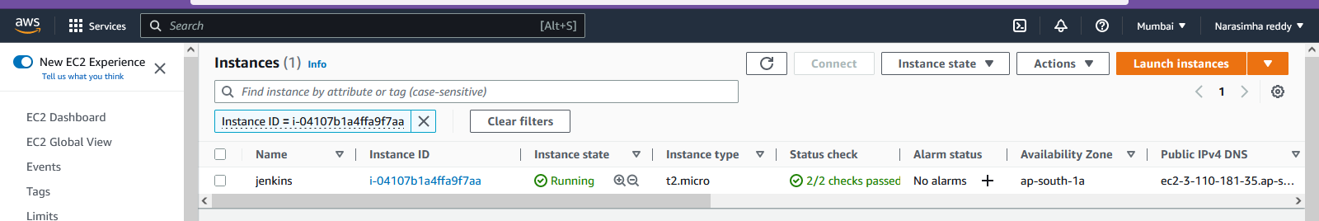

* After selecting instance ID ,here select security , click on that security groups ID .it will direct to the security group settings.
* Here click on edit inbond rule.

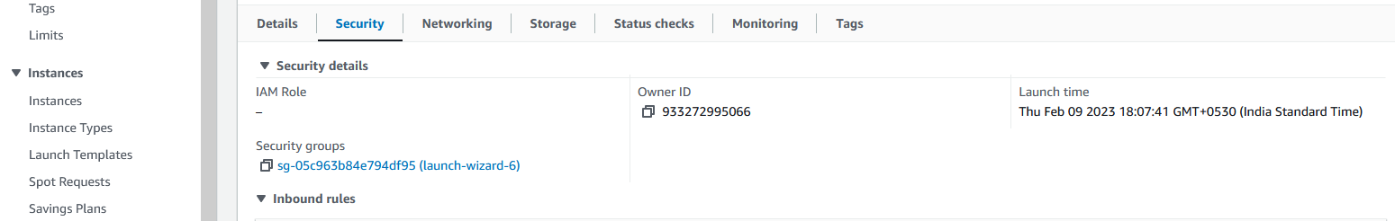

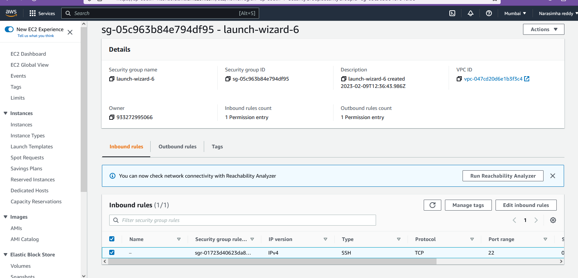

Click on add rule

* Select type as **custum TCP** and give port range **8080** , select source type as -anywhere
* Click on save rules

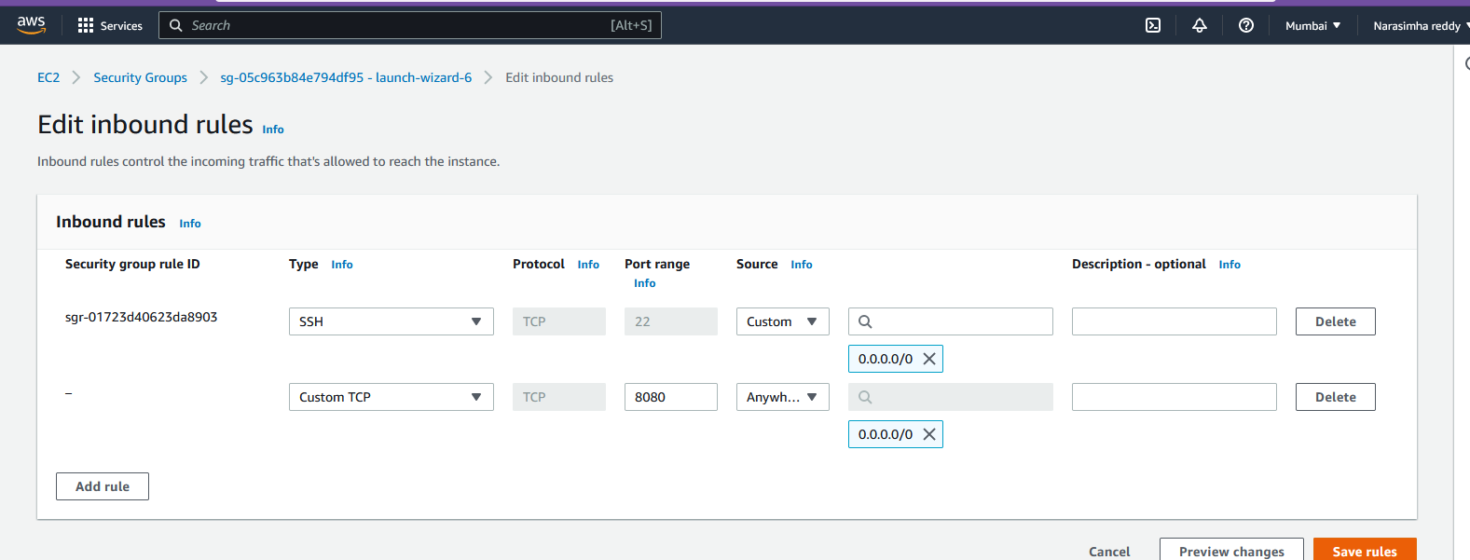

* Then login to instance through ip adress or dns adress(what ever you use ,ex- putty ,gitbash,amazon ci ,etc..)
* To install jenkins : prerequires are
  + Install java openjdk8 or above.
  + Install git
  + Jenkins repository
  + Jenkins CI
* First we have to update the your software packages are up to date on your instance by using ,
* **Yum update -y**
* Add the Jenkins repo using the following command:
* **wget -O /etc/yum.repos.d/jenkins.repo \** [**https://pkg.jenkins.io/redhat-stable/jenkins.repo**](https://pkg.jenkins.io/redhat-stable/jenkins.repo)

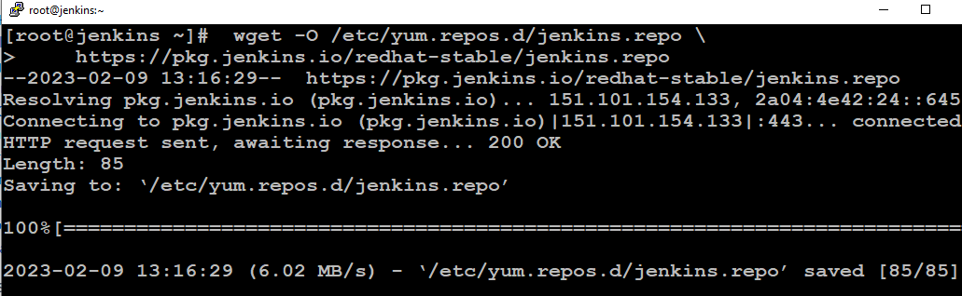

* Import a key file from Jenkins-CI to enable installation from the package:
* **rpm --import https://pkg.jenkins.io/redhat-stable/jenkins.io.key**
* Then upgrade this package using,
* **yum upgrade**

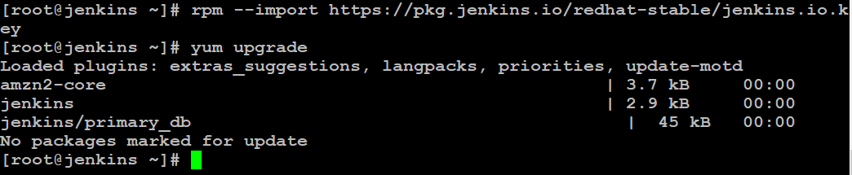

* install java : JAVA-OPENJDK11
* **amazon-linux-extras install java-openjdk11 -y**

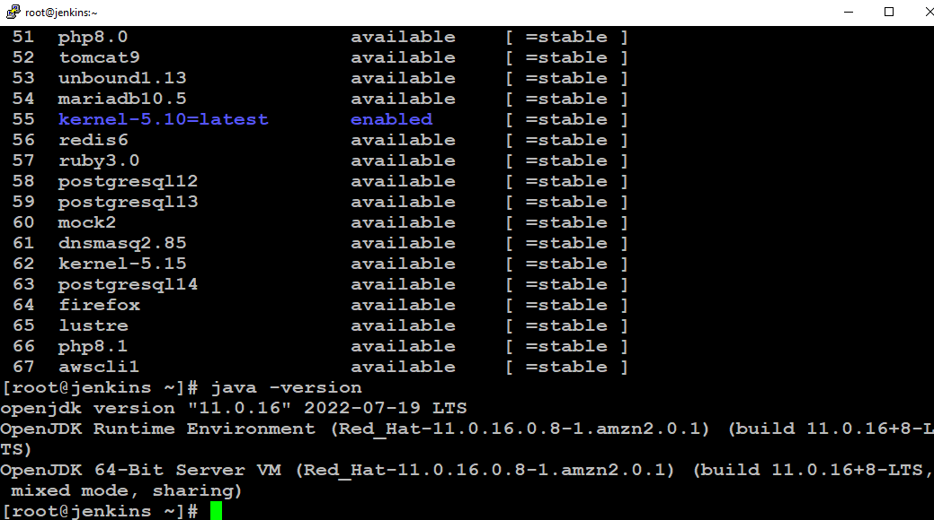

* **Install git :**
* **Yum install git**

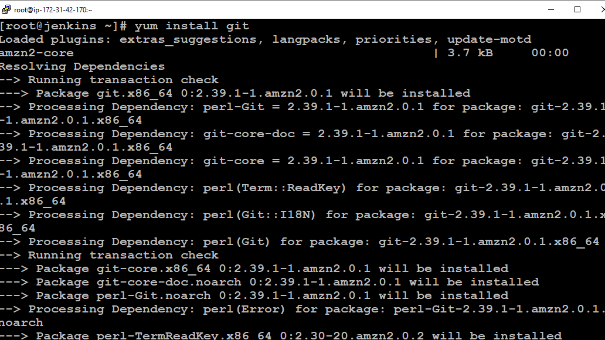

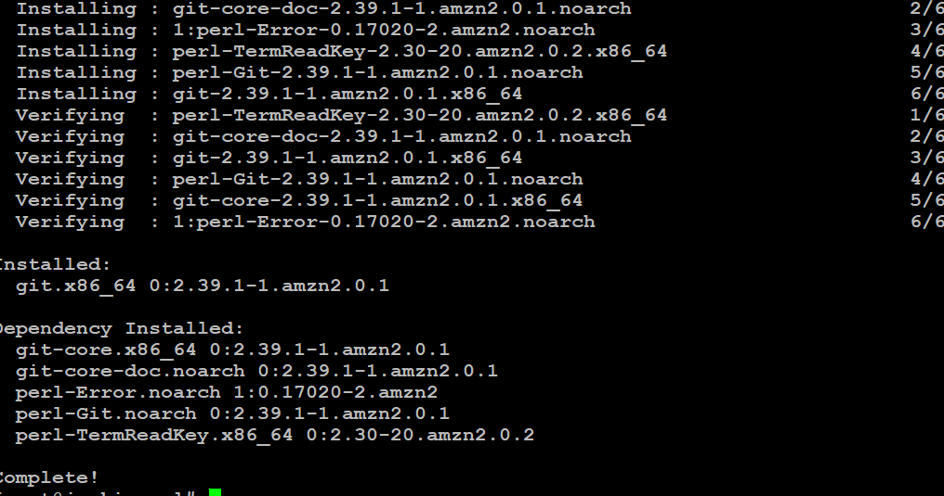

* install Jenkins:
* **yum install Jenkins -y**

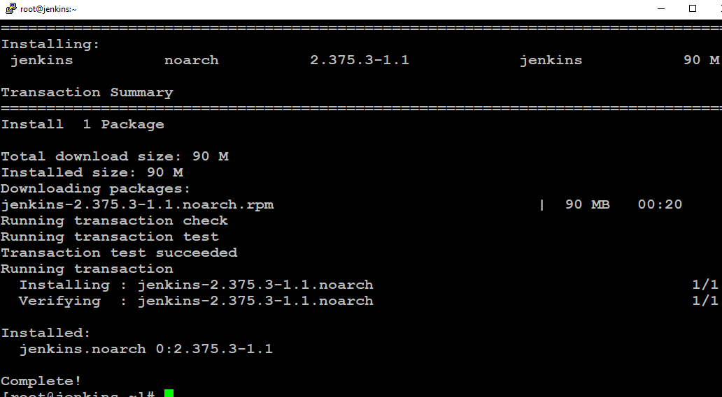

* Enable the Jenkins service to start at boot:

* **systemctl enable jenkins**
* Start Jenkins as a service:
* **Systemctl start jenkins**
* You can check the status of the Jenkins service using the command:
* **Systemctl status Jenkins**

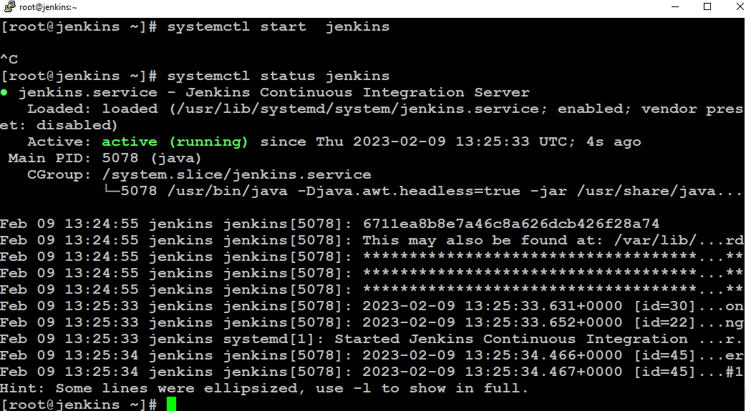

Jenkins is now installed and running on your EC2 instance.

To configure Jenkins:

* Connect to https server through **ip adress:8080** from your browser.
* You will be able to access Jenkins through its management interface.

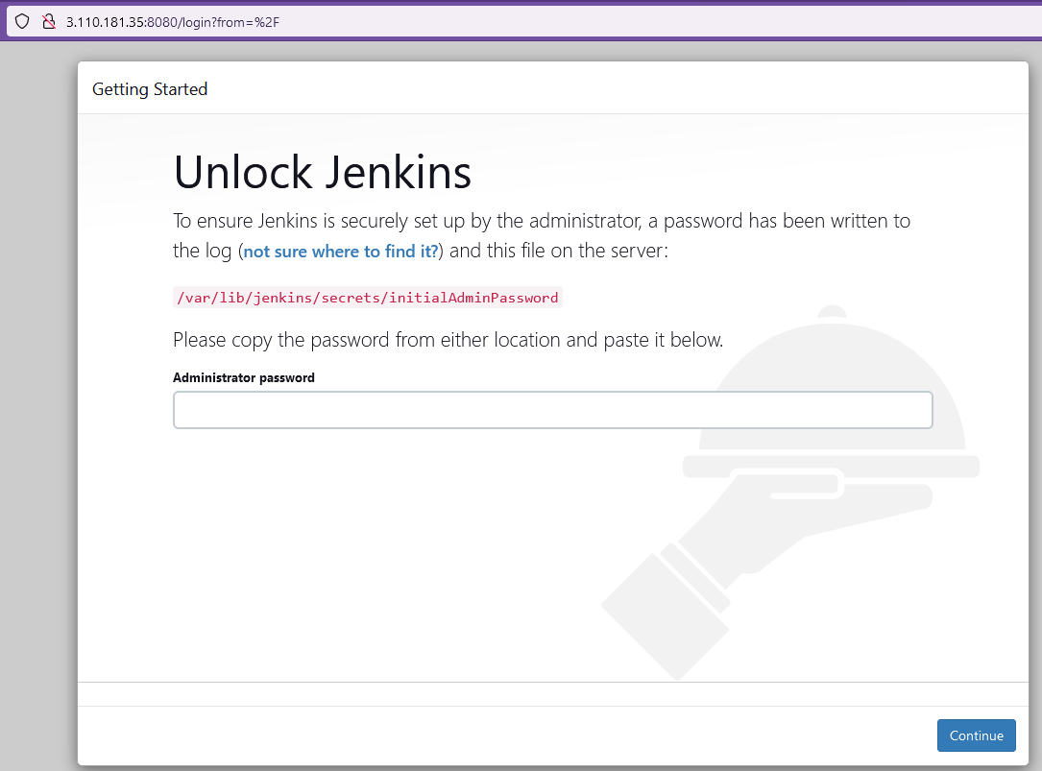

* Copy that file location and paste it instance server and open that file.
* Open that file using ,
* **cat /var/lib/jenkins/secrets/initialAdminPassword**

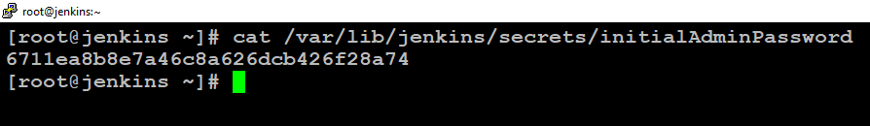

* here shows the password and copy that paste it over the above administrator password.
* Then cusmize Jenkins , here select the default **install suggested plugins**.

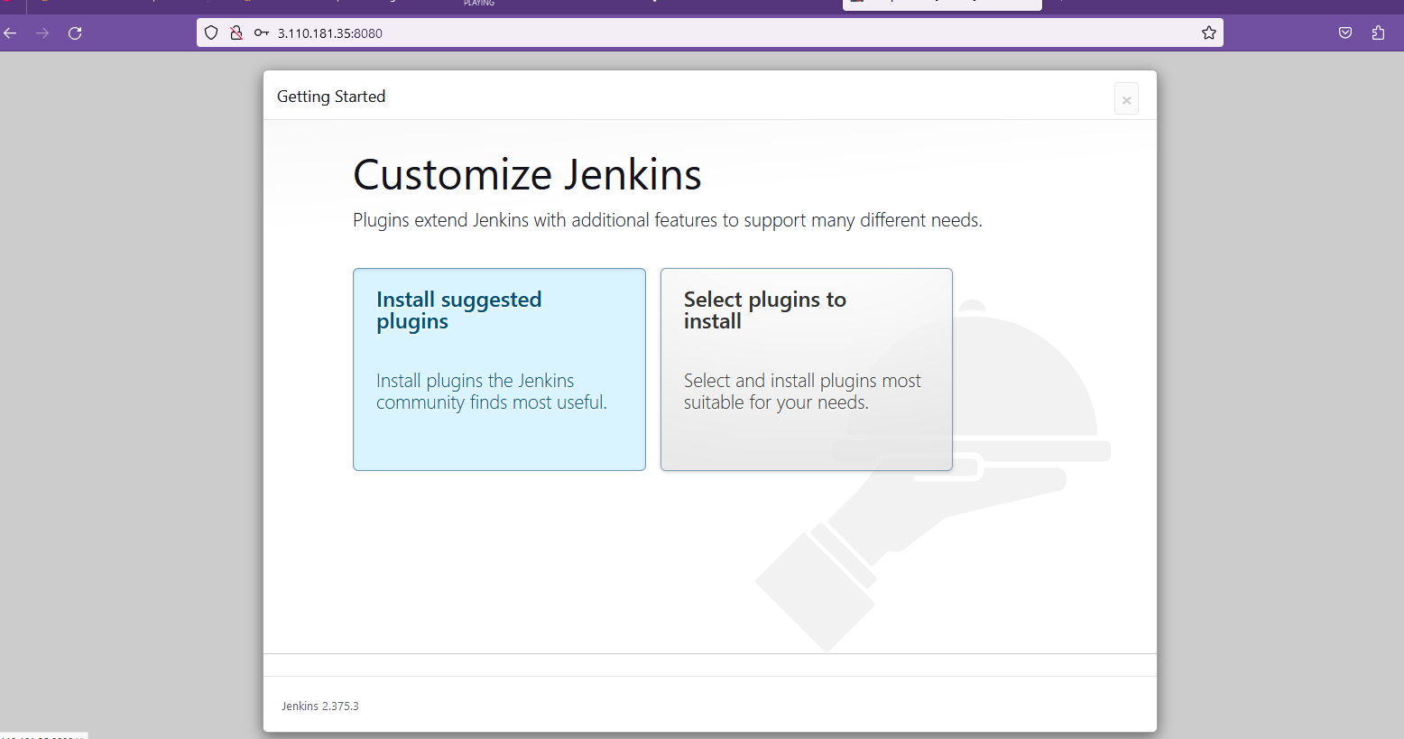

* Here shows selected install plugins.getting started

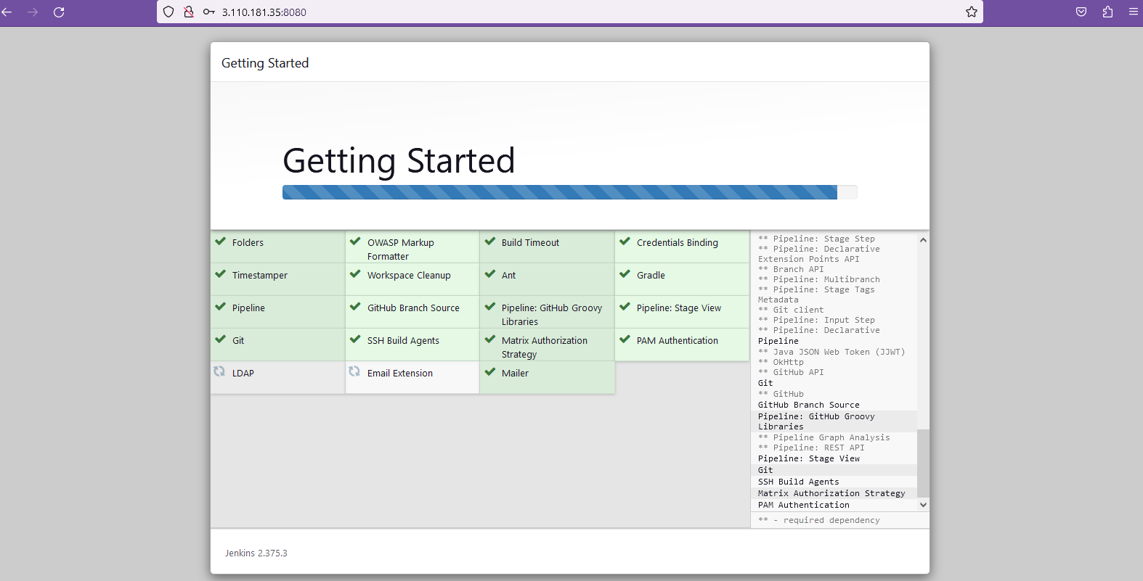

* Once the installation is complete, the **Create First Admin User** will open. Enter your information, and then select **Save and Continue**.

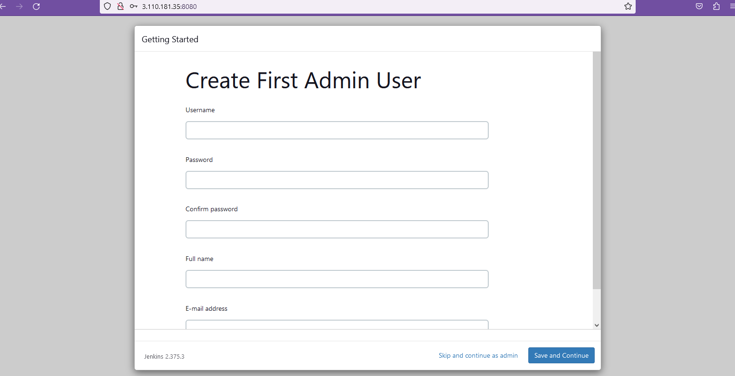

* Click on save and finish

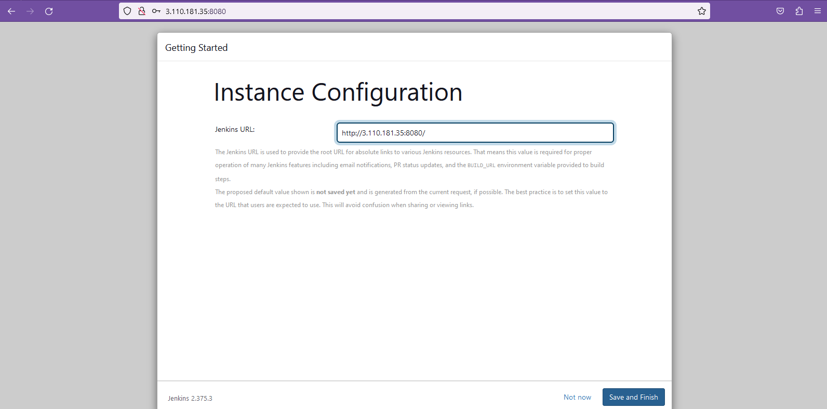

* Here we go ready to start the jenkins

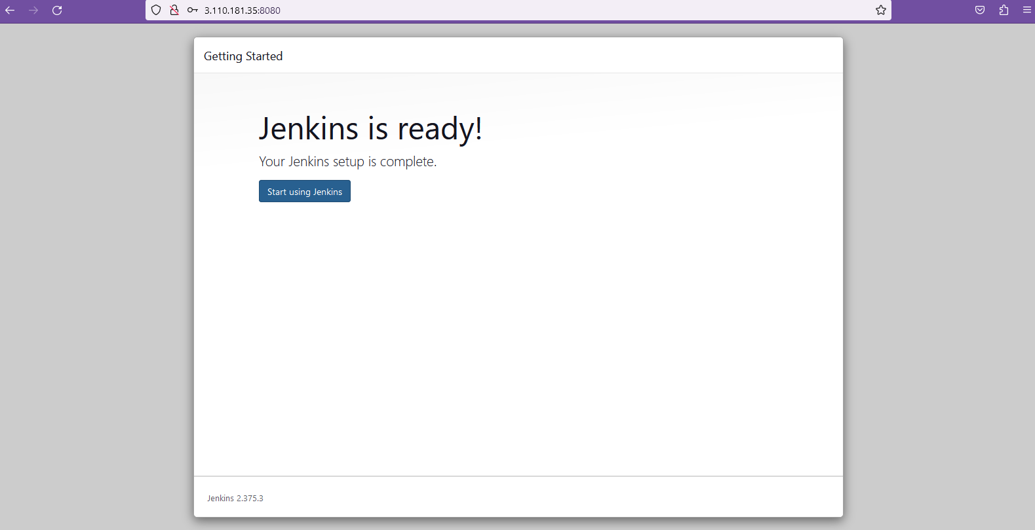

* Here the dashboard of the **Jenkins.**

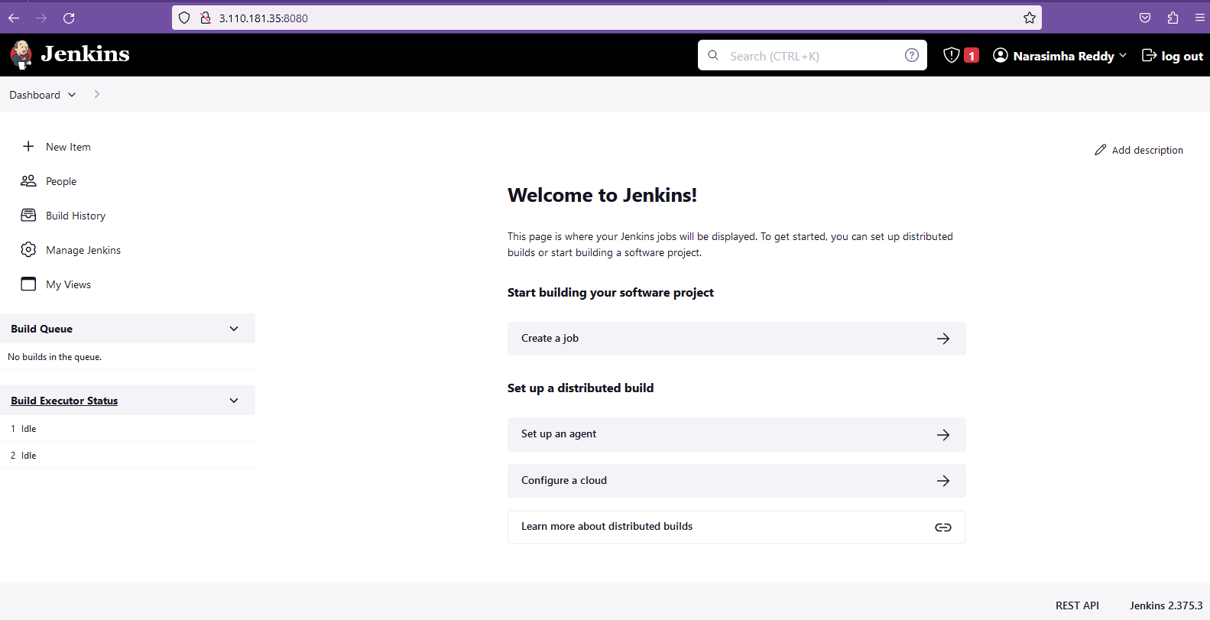

**finaly, we entered into the Jenkins dashboard**